X-Bee

We have started with Xbee pro series 2 . The basic working of the xbee is as follows

1.Power up the xbee. (Vcc at pin 1 and ground pin 10)

2.Connect the Din (data in pin 3) to the TX of the usart device.

3.Connect the Dout(data out pin 2) to the RX of the USART device.

4.Simillar connections for the other Xbee of same channel , PAN id , and corresponding destination addresses

Any byte sent through the USART to the Din pin of the Xbee would be immediately sent to the other Xbee and transferred through the Dout pin.

For acheiving these the following points should be ensured.

1.The PAN IDs of both the Xbees should be the same.

2.The destination address of one xbee should be the same as the address of the other Xbee.

3.One Xbee should be set as a co-ordinator and the rest of the devices as End devices or Routers or Remote Xbee.

4.The channel of both the Xbees should be the same.

A software by DIGI called X-CTU is used for reading and changing these above configurations.

There is a special FTDI breakout board for the Xbee . Through which we can connect it to the computer.

1.Connect the breakout board through USB to the computer and open the X-CTU . Set the baud rate and corresponding COM port and click on TEST QUERY .

2.Go to configurations tab and click read parameters ,note down the corresponding values of the Xbee (addresses ,channels ,PAN id etc.,). Similarly for the second Xbee.

3.Set the enable coordinator value to 1 for an Xbee and 0(end device) for another Xbee.

4.In the Destination address set the Address of the other XbeeDevice and make the channels same

and click on write parameters .

Now both the Xbees can communicate with each other.But when we first tried to do this when we clicked on test query after connecting to the PC. It showed a dialog box which said to press the reset button the XBee to continue. But pressing the reset button made no difference.(It should generally close when done so and show the details of the Xbee). Then it showed a message saying “unable to open COM port”. Even if we trid to read parameters a similar window popped up and the result was the same showing that it failed to read the parameters.

Then we followed this particular procedure found on a webpage.

Problems may occur when attempting to communicate with an XBee. The baud rate may be unknown, or the firmware within has disabled the serial port. If you work with the XBee AIO or DIO adapters, you will probably need to use this procedure.

You can help XCTU reflash the XBee by manually activating the XBee Bootloader.

1.Open an X-CTU Terminal Window

2.Change the baud rate to 115200

3.Assert/check DTR, De-assert/uncheck RTS, Assert/check Break

4.Hit the /RESET button on the XBee development board (example: XBIB)

5.De-assert/uncheck Break

6.Click on the Terminal Window tab, then Type a B and hit Enter or Carriage Return (the B must be upper case)

7.The XBee should return the Bootloader Menu that looks something like this:

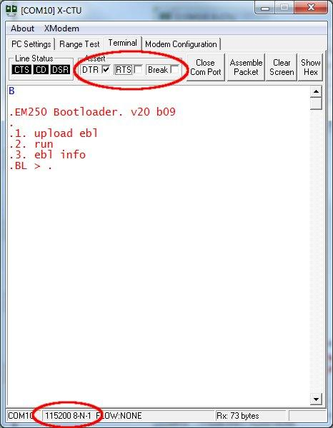

8.Without resetting or power cycling the XBee go to the Modem Configuration tab

9.Check Always Update Firmware & select firmware you wish to load

10.Click Write

Source:http://www.digi.com/support/kbase/kbaseresultdetl?id=3203

But this worked only with a Xbee and the other XBee was not responding to this procedure.

Then we were out of options and we did a hard reset of those Xbees.

Then we were able to read and write the parameters on the Xbees. Then after writing the parameters. We got a different problem whenever we are sending values from one Xbee to another Xbee .We are always recieving Zeros on the other side no matter whatever we send from one side.

This problem only appeared sometimes and was not seen some times.

Then we followed another process every time we connected the XBees. We powered up the Co-ordinator first and then after some time we powered the end device.This sometimes gave us good results some times.